**将结构改为类：**

#include "stdafx.h"

#include "stdafx.h"

#include<iostream>

using namespace std;

class student

{

public:

char name[20];

unsigned int id;

double score;

void input(student&stu);

void output(student&stu);

};

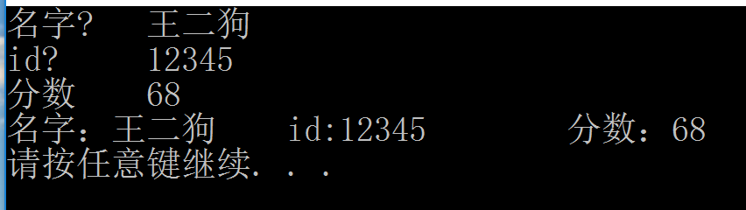void input(student&stu)

{

cout << "名字?\t";

cin >> stu.name;

cout << "id?\t";

cin >> stu.id;

cout << "分数\t";

cin >> stu.score;

}

void student::output(student&stu)

{

cout << "名字：" << stu.name << "\tid:" << stu.id << "\t分数：" << stu.score << endl;

}

int main()

{

student s;

s.input(s);

s.output(s);

}

**借书和还书**

#include "stdafx.h"

#include "stdafx.h"

#include<iostream>

using namespace std;

class book

{public:

char bookname[128];

double price;

void display();

void restore();

void borrow();

int number;

};

void book::display()

{

cout << "存书数量：" << number << endl;

}

void book::restore()

{

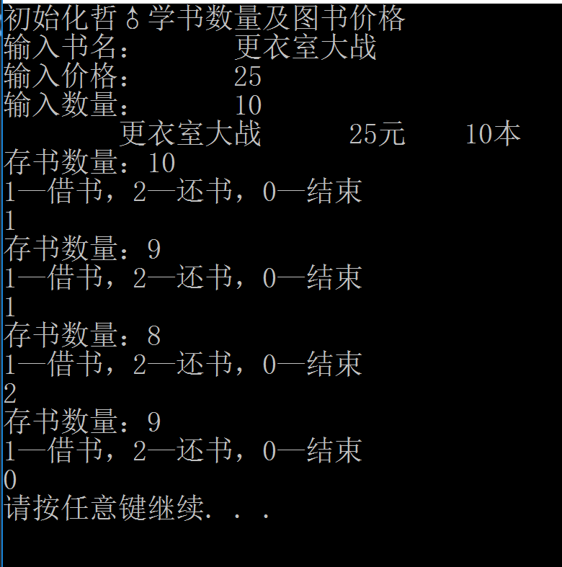 number++;

cout << "存书数量：" << number << endl;

}

void book::borrow()

{

number--;

cout << "存书数量：" << number << endl;

}

int main()

{

book philosophy;

cout << "初始化哲♂学书数量及图书价格\n";

cout << "输入书名：\t";

cin >> philosophy.bookname;

cout << "输入价格：\t";

cin >> philosophy.price;

cout << "输入数量：\t";

cin >> philosophy.number;

cout <<"\t"<< philosophy.bookname << '\t' << philosophy.price<<"元" << '\t' << philosophy.number <<"本"<< '\t';

cout << endl;

philosophy.display();

int x;

while (1)

{

cout << "1—借书，2—还书，0—结束\n";

cin >> x;

switch (x)

{

case 1:philosophy.borrow(); break;

case 2:philosophy.restore(); break;

case 0:return 0; break;

}

}

}

**学生统计程序**

#include "stdafx.h"

#include<iostream>

using namespace std;

class student

{

public:

int score[128];

static int total, count;

void scoretotalcount();

static int sum()

{return total;}

static int average()

{return total / count;}

};

void student::scoretotalcount()

{

int x;

while (1)

{

count = 0; total = 0;

cout << "1—输入学生成绩，0—结束程序输入\n";

cin >> x;

switch (x)

{

case 1:

{

cout << "请输入一个学生成绩\n";

cin >> score[count];

count++;

break;

}

case 0:goto fa♂; break;

}

}

fa♂:

for (int i = 0; i < count;i++)

{

total = score[i] + total;

}

}

int main()

{

student s;

s.scoretotalcount();

cout << "总成绩为" << s.sum << endl;

cout << "平均成绩为" << s.average << endl;

}

